Ex:No: 12

Date:

**TCL COMMANADS**

**Aim:**

To learn how to use various TCL commands Commit, Rollback and Savepoint

SQL commands

**Problem 1:**

Rollback to that state using the ROLLBACK command whenever required.

Create a following table Class and insert values into it in the order and create savepoints in between them. Try to rollback t the save point and check your output by giving select commands.

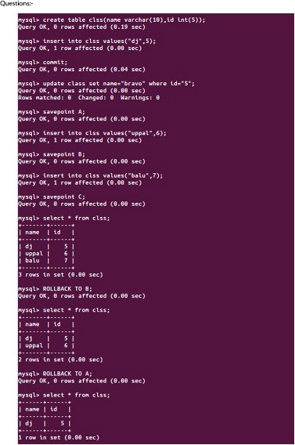

**Result:**

So now we know how the commands COMMIT, ROLLBACK and SAVEPOINT works.